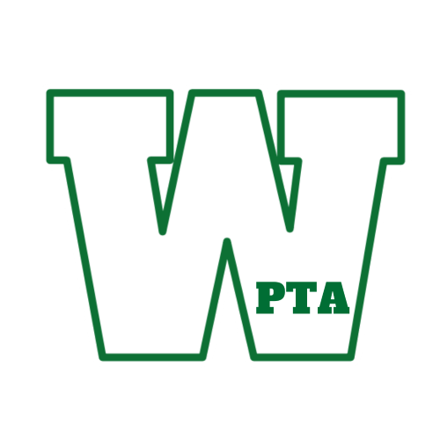
Woodland School District 50 PTA
November PTA Open Meeting Minutes

November 17th, 2022 9:30 am

Welcome
- Vice President Stephanie Ingram called the meeting to order at 9:34am
Reading & Approval of Minutes from October Meeting
- Minutes were presented by Stephanie Ingram, Principal Tim Sheldon made a motion to approve the October minutes and Kristin Michna seconded.
Treasurer’s Report
- Review of PTA Financials through October 31, 2022 were presented by Tracy Neish-Alonso, Principal Tim Sheldon made a motion to approve and Principal Ryan Wollberg seconded.

PTA Updates
- PTA Board Update
  - The former PTA board secretary Corri Wilson resigned her position. There is currently a vacancy for this role that the PTA is recruiting to fill.
- Fundraising:
  - Signature Chocolate – Fundraiser went very well. Pickup was on 11/11 and 11/12. There were approximately 50 orders left at pickup. Some have been delivered to schools for parent pickup.
  - Restaurant Fundraisers: Chuck E Cheese (12/2) – Fundraiser will be from 3-9pm. Principal Tim Sheldon will be attending.
- Good Night, Sleep Tight
  - This event will be taking place on 11/18 in the East Gym at Intermediate. It starts at 6:30pm, Chris Fascione (juggling storyteller) will be performing. Students are welcome to wear PJs and bring blankets and stuffed animals.
- Holiday Shop
  - Will be held on 12/8-12/9 at Intermediate MPR. Intermediate students will shop during the day and we will be open from 5:30-8:30 both evenigns for children of all ages to shop at night. All families can attend. We are looking for volunteers and a signup genius has been created and shared.
- Book Fair
  - Middle School book fair had $7000 in total sales and a $2000 cash profit. GREAT!
- DunkFest
  - Great event! Over 115 children attended and we had 28 teams from all over the area. Wiley had a dance off with a 6th grade student.
- Spirit Wear Online shop
  - There was approximately $750 in profit and items were shipped last Friday.
- PTA Special Projects budget
  - The schools still have most if not all of this money still available to spend. Primary has used some of this for their bike project.

Administrative Reports
- Primary
  - Celebrated Veterans Day with the student families/Ms. Byers(music teacher) and her dad was there to help explain the meaning of Veteran’s Day-respect, raising the flag. Families were asked to bring in pictures of Veteran’s and the made a wall of heroes out of the pictures. American Education week- today was hot chocolate/coffee bar for the staff. They have been also busy making “Grateful Grams”. Nov 29th Square Dancing Day for staff. Moving into Literacy routines/Independent Math Stations/Small group instruction/prep for conferences. They are raising money for the Holiday Food Drive/Baskets. $877 collected from staff. Practicing Restorative practices such as riding the bus and bus safety for the children.
- Elementary
  - Halloween parties were done on the same day but arranged by grades. Great feedback from parents. School Improvement leaders- Kyle Lees/veterans Day- local Veterans came in and spoke during P.E. or classes. Fundraiser $1835 collected for Spirit Week. Roar Store- big prizes- become a principal for the day by saving 500 tickets. Wiley has been making several appearances and is a favorite at the assemblies. Parent mentor program going well. Staff are participating in a Give & Get raffle to help with families in need. They are also taking part in a “feather hunt”- feathers are placed around the school and when you find one, you must write an encouraging word and then add to the turkeys. There was mention of discussing working on the sound system as part of the “special project”.
- Intermediate
  - Veteran’s Day activities/Essay contest winners(students). What Veteran’s Day means to me. The choir performed while kids sat with family as well as Veteran’s. Chief Smith was in attendance at Intermediate. They have had an assembly earlier. Fall play- Alice and Wonderland- every student got to see the play and it was also showing for 2 evenings. Musical auditions coming up soon. The band put on a concert( the first in 3 years) and had great performances. Working on MAP goals as well as “do your best” and try for that goal.
- Middle School
  - Veteran’s Day- Teachers focused on activities and everyone took a moment of silence on 11:11 a.m. and spoke about the importance of celebrating Veteran’s Day. Students, through Schoology, were allowed to participate in checking out National Monuments and were awarded prizes. Some even made cards for Veteran’s and decorated “poppy’s” in the foyer. Students of Service raked leaves for the elderly. Honor roll almost 900 students 1st Quarter! 19 teams are working with Mrs. Drake about Academics. Dec 2nd assembly P.B.I.S. committee recognizing all students in the following: fall sports teams, honor roll, student of the month/ a Cross-Country student placed in state and there’s talk about having a Basketball game/free throw contest/or 3 points. Working on better culture and climate of building.
- Superintendent
  - Attended the different Veteran’s Day activities. Schools did a great job. Attended the Dist 50 Covid Symposium at the University- How to get through the Pandemic safely. Possible talk of changing SIP days. Planning on family feedback on community what we are doing well and what we could improve on. Annual conference downtown- board as well as some District Administrators will be attending(Fri-Sun)

Community Update
- Brooke Hagstrom – Communications Manager
  - Holiday food drive already receiving donations. There will be 4 busses at the grocery stores from 4:30-7:30 and will be accepting any non-perishable items and are trying to fill the bus
- Anna Chang-Yen – District Board of Education
  - In the process of strategic planning for 2023. Coming up soon- hearing from the community about input and feedback.

Open Discussion
The meeting was adjourned at 10:30am

Next Meeting: Thursday December 15th, 9:30am at ESC

Contact dist50pta@gmail.com for more information or questions.

